What’s on at Dyscover – Spring 2023
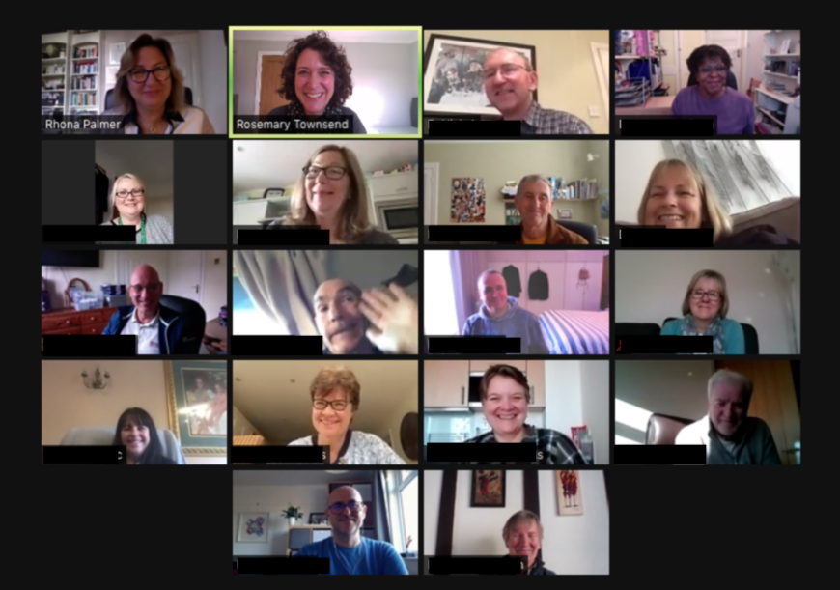
VIRTUAL VISITOR SESSION ON ZOOM.
On Tuesday 7th February At: 10.30am - 11.30am
Meet Rhona, hear about our service plans and meet some of our inspiring Aphasia Ambassadors Booking essential via info@dyscover.org.uk to reserve your place and receive the Zoom link.
This Spring Term we are continuing to offer regular face-to-face and Zoom groups. Roughly a third of our members are connecting on Zoom, two-thirds in person at Leatherhead or Kingston.
Our 12-week term runs from 9th January until 31st March.
New referrals can be taken at any point throughout the term. See over for referral information.
Recognising that the needs of people with aphasia change over time. We continue to provide different groups for different stages of recovery. Our three core programmes are called Foundation, Extend and Sustain, which are run according to need. See below for this term’s groups.
Our Challenge Programme runs alongside our communication groups for regular members. This term we are offering 10 weeks of supported Shooting at Bookham Rifle Club and online Pilates, with our fantastic instructor Natalie.
Dyscover at Home Online groups via Zoom | Face-to-Face groups Leatherhead / Kingston
- Tuesday mornings 10.00am -11.15am  - Tuesday afternoons 2.30pm - 4.00pm  - Thursday mornings 10.00am -11.15am  - Reading Group – Thursday mornings 10.30am - 11.30am | At the Kingston Quaker Centre KT1 2PT  - Tuesday mornings 10.00am -12.00 noon  At Leatherhead Court KT22 0BN  - Wednesday mornings 10.00am - 12.30pm  - Wednesday afternoons 2.00pm - 4.00pm  - Thursday mornings 10.00am - 12.30pm  - Thursday afternoons 2.00pm - 4.00pm
EXPANDING OF SERVICES FOR PEOPLE LIVING WITH PPA (Primary Progressive Aphasia)
Our PPA service is receiving about 5 referrals a month. Relatives or health professionals wishing to refer can find out about our support from Dyscover’s website https://www.dyscover.org.uk/wp-content/uploads/PPA-service-launch-flyer-Sept-22.pdf. Your FAQs about our PPA service may be answered here (https://www.dyscover.org.uk/wp-content/uploads/PPA-FAQs-1.pdf-1.pdf) If you would like to chat before making a referral, please contact Rosemary Townsend at rtownsend@dyscover.org.uk
In January, we are looking forward to running an in-person course at Leatherhead for a group of couples living with PPA.
Expanding our Online Groups
We have exciting plans to expand our online aphasia service, in order to meet the needs of people who do not currently have access to long-term aphasia support. We have been busy collecting data and consulting colleagues across the NHS and voluntary sector to understand better what the need is and how we can best work together to bridge the gaps. Huge thanks to all those who have taken part in our e-survey and shared their expertise and thoughts. Your views are helping us to shape our plans and design our online service to best meet the need. If you would like to share your views, express an interest, join our SLT advisory group, or work in partnership with us, we would love to hear from you. Please contact Lin at lcockayne@dyscover.org.uk.
You can also find out more or complete the e-survey on our website: Dyscover Online Project - Dyscover
COLLABORATION WITH THE IRISH HEART FOUNDATION
We are now reaching the end of our second “Living Well with Aphasia Course” which we design and deliver in collaboration with the Irish Heart Foundation. Our Speech and language Therapist, Barbara Greenwood is delighted that the courses have been so well received and is now planning 2 further 12-week courses for 2023.
CHARGES - Dyscover is a charity, and our services are subsidised by grants. We ask for a contribution from members. Our charges range from £14.50 to £19 per session, paid termly, for online post stroke aphasia groups.
CONVERSATION PARTNER TRAINING. We tailor our conversation partner training according to the needs of people referred to us. We charge £200 for an individualised 4-session course of Conversation Partner Training with a specialist Speech and Language Therapist.
In 2023 we would like to provide a group option for Conversation Partner Training. It has been shown that people with Aphasia benefit early on from exploring the challenges of learning to live with Aphasia alongside supportive family and friends. Working together with others shows positive changes in maintaining effective and most importantly enjoyable conversations.
TO REFER OR ENQUIRE
Please check our referral FAQs https://dyscover.org.uk/pdfs/referral-faq.pdf
To refer, complete our online referral form and email to snortham@dyscover.org.uk https://dyscover.org.uk/pdfs/Dyscover_referral_form.pdf
To enquire, phone us, or email info@dyscover.org.uk
CONTACT US
Our offices in Leatherhead are staffed 4 days a week, with 24hr answerphone
Dyscover Limited, Leatherhead Court, Woodlands Road, Leatherhead KT22 0BN
Phone 01737 819419 Email: General enquiries info@dyscover.org.uk
Service-related enquiries and referrals Rhona Palmer rpalmer@dyscover.org.uk
For updates, see News Alerts on our website www.dyscover.org.uk

