What’s on at Dyscover – Autumn 2023

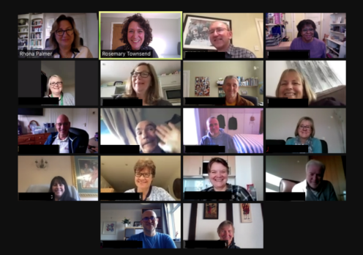
Virtual Information Session on Zoom on
Tuesday 7th November 10.30am - 11.30am
Meet Rhona, hear about our service plans and meet some of our inspiring Aphasia Ambassadors. Booking essential via info@dyscover.org.uk to reserve your place and receive the Zoom link.
Primary Progressive Aphasia Specific Information Session on Zoom on
Wednesday 27 September 10.30am - 11.30am
Meet our PPA Specialist Rosemary Townsend and learn more about Dyscover's service and ask questions. There will also be an opportunity to hear from people living with PPA. Please email Rosemary Townsend at rtownsend@dyscover.org.uk if you would like to attend.

This Autumn Term we are running the following groups:

Dyscover at Home Online groups via Zoom | Face-to-Face groups Leatherhead / Kingston
14 weeks from 4th September to 8th December 2023
- Tuesday mornings; 10.00am - 11.15am  - Tuesday afternoons; 2.30pm - 3.45pm  - Thursday mornings; 10.00am - 11.00am  - Reading Group – Thursday mornings; 11.30am – 12.30pm | At the Kingston Quaker Centre KT1 2PT  - Tuesday mornings; 10.00am -12.00 noon  At Leatherhead Court KT22 0BN  - Wednesday mornings; 10.00am - 12.30pm  - Wednesday afternoons; 2.00pm - 4.00pm  - Thursday mornings; 10.00am - 12.30pm  - Thursday afternoons; 2.00pm - 4.00pm
Charges - Dyscover is a charity and our services are subsidised by grants. We ask for a contribution from members. Our charges range from £15.50 to £20 per session, paid termly. Charges are higher for our individual PPA assessments and interventions.

New referrals can be taken at any point throughout the term. See over for referral information.
Recognising that the needs of people with aphasia change over time. We continue to provide different groups for different stages of recovery. Our three core programmes are called Foundation, Extend and Sustain, which are run according to the needs of our members / those people newly referred, and following individual assessment by one of our SLTs.
Our Challenge Programme runs alongside our communication groups for regular members. This term we are offering 10 weeks of supported Golf, Pilates and Gymnastics and Movement.

Space available in Autumn Online Groups
We have recently offered a new online group on Thursday Mornings from 10.00am – 11.00am for people who have encountered Aphasia relatively recently. This has evolved into a fun and friendly Extend group for people who are ready to enhance their stamina in conversation and take on new
communication challenges in a supportive online environment. Please do refer if you know someone who would enjoy this opportunity.

Services for People Living with PPA (Primary Progressive Aphasia)
Last term we carried out 8 assessment and advice sessions, 9 Communication Partner Training sessions, and 1 troubleshooting review. We also ran 2 peer ‘mixer’ sessions for a total of 39 people living with PPA. Most of our support is delivered in person at Leatherhead, but we also work online. Relatives or health professionals wishing to refer can find out about our support from Dyscover’s website:
https://www.dyscover.org.uk/wp-content/uploads/PPA-service-launch-flyer-Sept-22.pdf

Your FAQs about our PPA service may be answered here:
https://www.dyscover.org.uk/wp-content/uploads/PPA-FAQs-1.pdf-1.pdf
If you would like to chat before making a referral, please contact Rosemary Townsend at rtownsend@dyscover.org.uk

Collaboration with the Irish Heart Foundation
Our next “Living Well with Aphasia Course”, designed and delivered in collaboration with the Irish Heart Foundation will start in November. SLT Barbara Greenwood will work alongside staff and volunteers from the IHF and one of our Speech and Language Therapy Assistants to deliver a 12-week course, which involves both people with aphasia and their relatives for the first few sessions.

Relatives’ Support
We continue to offer a termly relatives’ support meeting with the SLT lead for individual groups, both face-to-face and online. This allows family or friends to meet up and share thoughts with other relatives from whichever group which they have in common. As always, our door is open at all times for relatives to raise any concerns.

Staff News
We are delighted to welcome a new Service Manager and Lead Speech and Language Therapist, Julie Samuel from the start of October.

Social Media
In June, we launched @dyscoveraphasia on Instagram to coincide with International Aphasia Awareness Month. We were keen to give our members the opportunity to describe their experiences and the range of ways that Dyscover has supported them. We look forward to continuing to share what we do to improve understanding of Aphasia and its impact. Please do follow instagram.com/dyscoveraphasia to stay up to date with what’s going on at Dyscover.

To refer or enquire about our services:
Please check our referral FAQs: https://dyscover.org.uk/pdfs/referral-faq.pdf
Complete our online referral form https://dyscover.org.uk/pdfs/Dyscover_referral_form.pdf
and email to: info@dyscover.org.uk
To enquire either email info@dyscover.org.uk or contact us as below:
Contact Us:
Our offices in Leatherhead are staffed 4 days a week, with 24hr answerphone.
Dyscover Limited, Leatherhead Court, Woodlands Road, Leatherhead KT22 0BN
Telephone: 01737 819419
General enquiries info@dyscover.org.uk
Service-related enquiries to Rhona Palmer rpalmer@dyscover.org.uk
Referrals to be sent to info@dyscover.org.uk
For updates, see News & Alerts on our website: dyscover.org.uk

